Charge Back Calculation
Use Case Document


 | Prepared By / Last Updated By | Reviewed by | Approved By
Name | Rahul Kumar | Person 2 | Person 3
Role | Team Member | Team Member | Scrum Master
Signature
Date

Table of Contents
1.0 Introduction 3
1.1 Purpose & Scope of the document 3
1.2 Intended Audience 3
1.3 Use case ‘User Registration’ 3
1.3.1 Use case attributes 3
1.3.2 Use Case Model 4
1.3.3 Business Rules 4
1.3.4 UI Requirements 4
1.3.5 UI Field Validations 5
1.4 Use case ‘User Credential Authentication’ 6
1.4.1 Use case attributes 6
1.4.2 Use Case Model 7
1.4.3 Business Rules 7
1.4.4 UI Requirements 7
2.0 Database Design 8
2.1 Tables Structure 8
3.0 Change Log 10

Introduction

Purpose & Scope of the document
The purpose of this Use case document is to systematically capture requirements for the project and the system to be developed in terms of use cases. Functional use cases are captured in this document. It also serves as the input for the project scoping.

The scope of this document is limited to addressing the use cases from a user, quality, and non-functional perspective.

Intended Audience
Each member of the project team

Use case ‘User Registration’

Use case attributes
Use Case Description:

This use case deals with the capture of Bank Representative user details. The ‘Bank Representative user’ here shall be the operator of the system and will be keying in the customers’ chargeback information into the system.

Scope:

- Bank Representative user registration

Actors:

- Bank Representative User – the operator

Trigger:

Click ‘Submit’ button in the ‘User Registration’ page

Pre-Condition:

User being able to access the homepage & get redirected to the ‘User Registration’ page upon click of ‘Register if new’ link.

Post Condition:

User is in the enrollment page & submit details

Flow of Events:

User at homepage → Click ‘Register if new’ link → User is in the enrollment page → User details are submitted and added onto the database

Primary Scenario:
A new user – is able to click ‘Register if new’ link and able to provide his details and get enrolled in the system.

Use Case Model
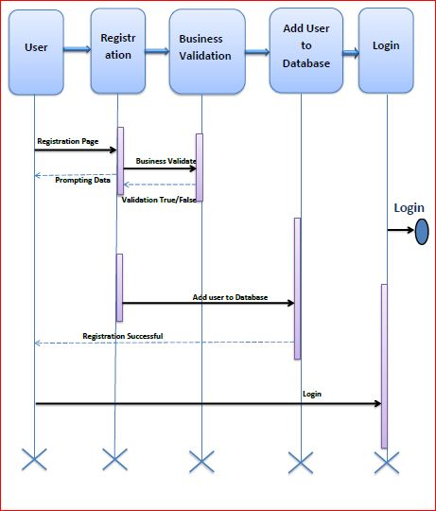

Business Rules

Business rules should be defined using the following attributes: -

- When the user clicks on the registration link, it should re-direct to registration form.
    - User needs to fill some of the basic attributes/fields as mentioned below in requirement: First Name, Last Name, Age, Gender, Contact Number, City, State, User Id, Password
- Clicking ‘Submit’ should validate the datatype constraints for each field
- Post-successful field level validation, save the information in the database
Upon saving the information in the database, display the message “New user created sucesfully”.

UI Requirements
Here is a prototype on how the homepage should look like.

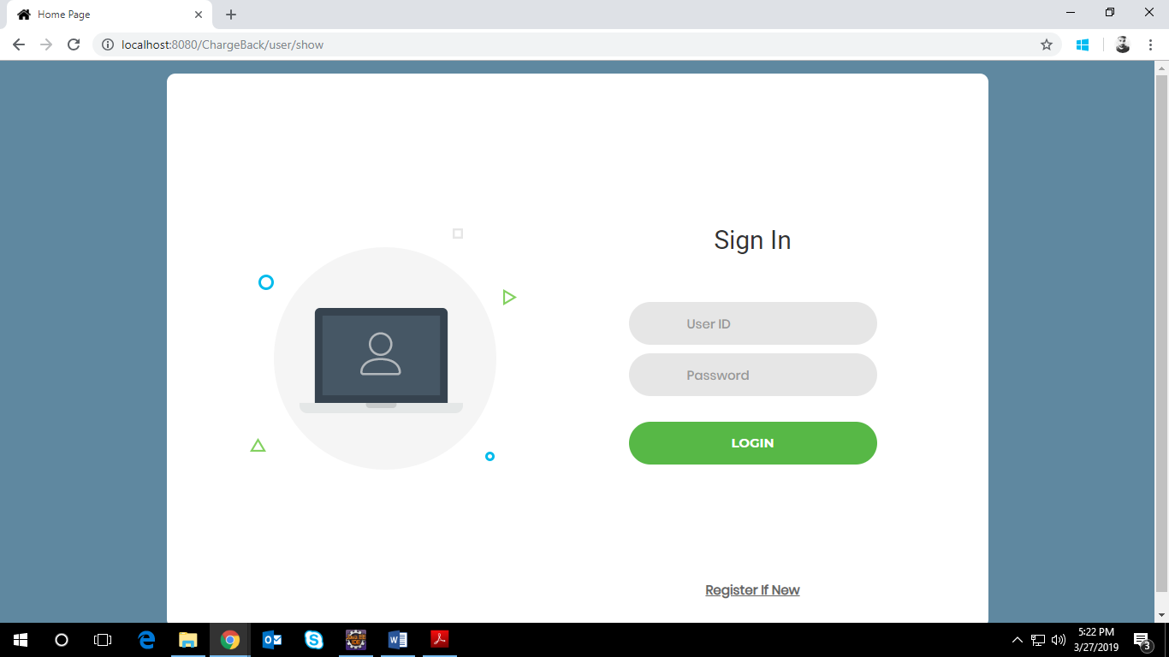

Here is a prototype on how the ‘User Registration’ page should look like.

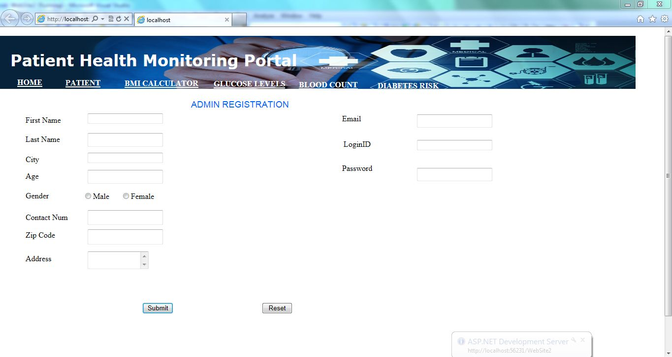

UI Field Validations
Please refer to the below requirements for field level validations:

- All fields are mandatory.
- Username should be less than 30 chars. Password should have minimum 8 chars, no space & can contain special characters (ex.!, @,#,%,*,& etc.).
- Phone Number must be of 10 digits’ length.
- Invalid fields must be marked in red with alert message.

Use case ‘User Credential Authentication’

Use case attributes
Use Case Description:

This use case deals with the authentication of the user credentials. The ‘user’ here shall be the operator of the system

Scope:

- User credentials authentication

Actors:

Bank Representative User – the operator

Trigger:

Click ‘Login’ link, after keying in ‘User ID’ & ‘Password’ field.

Pre-Condition:

Bank Representative User being able to access the homepage

Post Condition:

Bank Representative User is in the Customers’ Details page

Flow of Events:

Bank Representative User at homepage → Key in ‘User ID’ & ‘Password’ field → User credentials are validated → Customers’ details page is displayed

Primary Scenario:
A registered Bank Representative user – is able click ‘Login’ link, after keying in ‘User ID’ & ‘Password’ field and get his credentials authenticated with the existing database entry.

Alternative Scenario:
A registered Bank Representative user – is able click ‘Login’ link, after keying in ‘User ID’ & ‘Password’ field and unable to get his credentials authenticated. The user is presented with relevant error messages:

- Invalid User ID – ‘The user ID provided does not exist in our records’
- Incorrect Password – ‘Password provided is incorrect. Please reach out to your system admin.’

Use Case Model

Business Rules
Business rules should be defined using the following attributes:-

- A registered Bank Representative user – is able click ‘Login’ link, after keying in ‘User ID’ & ‘Password’ field and get his credentials authenticated with the existing database entry

Use case ‘Customer Details Display Page’

Use case attributes
Use Case Description:

This use case deals with the page showing list of customers with their details . The ‘user’ here shall be the operator of the system and will be keying in the patient information into the system.

Scope:

- User credentials authentication

Actors:

Bank Representative User – the operator

Trigger:

Click ‘Login’ link, after keying in ‘User ID’ & ‘Password’ field.

Pre-Condition:

Bank Representative User being able to access the homepage

Post Condition:

Bank Representative User is in the Customers’ Details page

Flow of Events:

Bank Representative User at homepage → Key in ‘User ID’ & ‘Password’ field → User credentials are validated → Customers’ details page is displayed

Primary Scenario:
A registered Bank Representative user – is able click ‘Login’ link, after keying in ‘User ID’ & ‘Password’ field and get his credentials authenticated with the existing database entry.

Alternative Scenario:
A registered Bank Representative user – is able click ‘Login’ link, after keying in ‘User ID’ & ‘Password’ field and unable to get his credentials authenticated. The user is presented with relevant error messages:

- Invalid User ID – ‘The user ID provided does not exist in our records’
- Incorrect Password – ‘Password provided is incorrect. Please reach out to your system admin.’

Use Case Model

Business Rules
Business rules should be defined using the following attributes:-

- A registered Bank Representative user – is able click ‘Login’ link, after keying in ‘User ID’ & ‘Password’ field and get his credentials authenticated with the existing database entry

Database Design

Tables Structure
Bank Representative Registration:
Column Name | Data Type | Length | Nulls
User Id | varchar | 50 | N
Password | varchar | 50 | N
First Name | varchar | 50 | N
Last Name | varchar | 50 | N
Age | int | 2 | N
Gender | varchar | 10 | N
Contact Number | varchar | 10 | N
City | nvarchar | 50 | N
State | nvarchar | 50 | N

Bank Representative User login:
Column Name | Data Type | Length | Nulls
User Id | varchar | 50 | N
Password | varchar | 50 | N
To be Edited in Customer details
Customer Details:
Column Name | Data Type | Length | Nulls
Patient Id | varchar | 10 | N
Username | nvarchar | 50 | N
Password | nvarchar | 50 | N
Date Of Birth | date |  | N
Email Address | nvarchar | 50 | Y
Contact Number | varchar | 10 | N
Address | nvarchar | 250 | N
City | nvarchar | 50 | N
Country | nvarchar | 50 | N
Pincode | varchar | 10 | N
Gender | varchar | 10 | N
Guardian First Name | nvarchar | 50 | N
Guardian Last Name | nvarchar | 50 | Y

Change Log
Version Number | Changes Made
V1.0 | Initial baseline created on <dd-Mon-yy> by <Name of Author>
V1.1 | <Please refer the configuration control tool / change item status form if the details of changes are maintained separately. If not, the template given below needs to be followed>
V1.1 | Section No. | Changed By | Effective Date | Changes Effected

